|  |
| --- |
| IFMR RURAL FINANCE |
| Screening Review |
|  |
| **IFMR Rural Finance** |
| **10/19/2016** |

|  |
| --- |
|  |

Contents

1. Process Diagram 3

1.1 Process flowchart 3

1.2 Process Steps 4

2. Stage definition 4

3. Stage-role access 4

4. Screening review Queue 5

4.1 UI specification 5

4.2 Screenshot 6

4.3 Functional requirements 7

4.4 Upload 7

4.5 Download 7

4.6 Reports 7

5. Reviewing Screening stage data 8

5.1 UI requirements 8

5.2 Screenshots 20

5.3 Functional requirements 39

5.5 Downloads 39

5.6 Reports 39

# Process Diagram

# Process flowchart



# Process Steps

1. Central Risk Manager Logs in and is able to view all profiles for which de-dupe is successful and CB check and Risk Score 1 have been computed.
2. CRM can search profiles based on the following criteria
   * + Screening date
     + Applicant Name
     + Business Name
     + Customer ID
     + Area
     + City /Village/Town
     + Pincode
3. All search parameters will have a sort/arrange facility
4. CRM will click on the desired profile to select the customer. Screening data of that customer will be auto-populated and summary will be displayed.
5. CRM will review the scores and the screening details
6. CRM will click on **‘+ remarks’** to add remarks
7. In the remarks section, the CRM can select a remark from the dropdown list.
8. The CRM can also enter deviations in the text box provided.
9. After entering the remarks, the CRM can choose to Accept/Reject/Hold/Send Back the profile.
10. Accept- will send the profile to the next stage, i.e. Application
11. Reject – will send the profile to the Rejected Application Queue
12. Hold – will hold the profile in the screening review queue with a tag ‘HOLD’, until further action
13. Send Back – will send the profile back to Screening stage will the remarks added by the CRM

# Stage definition

|  |  |
| --- | --- |
| **Stage** | **Description** |
| Screening Review Queue | The Central Risk Manager selects a profile from the pending for screening review queue |
| Customer View | The Central Risk Manager reviews data and can submit the same for application/ reject/ send back to screening stage / hold in screening review queue until further action. |

# Stage-role access

|  |  |
| --- | --- |
| **Stage** | **Applicable Role** |
| Screening Review Queue | Central Risk Manager |
| Customer View | Central Risk Manager |

# Screening review Queue

## UI specification

|  |  |  |  |  |
| --- | --- | --- | --- | --- |
| **Field name** | **Section** | **Data Type** | **Attribute** | **Population logic** |
| Applicant Name | Central Risk Manager Queue | Text | Sort/search | From screening stage |
| Business Name | Central Risk Manager Queue | Alphanumeric | Sort/search | From screening stage |
| Customer ID | Central Risk Manager Queue | Alphanumeric | Sort/search | From screening stage |
| Area | Central Risk Manager Queue | Text | Sort/search | From screening stage |
| City/Village/ Town | Central Risk Manager Queue | Text | Sort/search | From screening stage |
| Pincode | Central Risk Manager Queue | Numeric |  | From screening stage |

## Screenshot

* + 1. Search Page

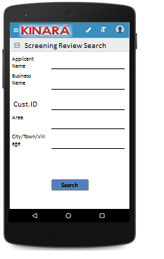

* + 1. Application Queue

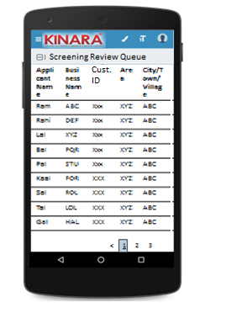

## Functional requirements

Central Risk Manager logs in

* The Central Risk Manager opens the process dash board, and clicks on Screening Review Queue
* If the Central Risk Manager performs a search without selecting any parameter, then all cases with status ‘Pending for Screening Review’ to be displayed in a tabular format.
* If the Central Risk Manager searches with ‘Applicant name’, ‘Business name’ or ‘Customer ID’, then all matching records that are ‘Pending for Screening Review’ to be displayed in a tabular format.
* The Central Risk Manager can **search and sort** the profiles based on the following parameters: Customer ID, Applicant Name, Business Name, Area, City/Village/Town.
* The Central Risk Manager then selects a profile from the application queue. The queue table should have applicant name, business name, Customer ID, Area, City/Town/Village as column names.
* All the columns will have **sorting** facility.

## Upload

-NA-

## Download

-NA-

## Reports

-NA-

# Reviewing Screening stage data

## UI requirements

|  |  |  |  |  |  |  |  |  |  |
| --- | --- | --- | --- | --- | --- | --- | --- | --- | --- |
| **Entity** | **Tab** | | **Sub tab** | **Fields** | | **Field Value** | **Mandatory** | **Conditional Mandatory** | **Remarks** |
| **Summary** | **Risk Score** | |  | Risk Score 1 | | Numeric |  |  |  |
| **CB Check Report** | |  |  | |  |  |  |  |
| **Remarks** |  | |  | Remarks | | Drop down | Yes |  |  |
| Deviations | | Free text |  |  |  |
| **Applicant** | **Applicant Profile** | | **KYC Details** | Aadhar No | | Numeric | Yes |  | From Screening |
| Document Capture | | Upload | Yes |  | From Screening |
| Pan Number | | Alpha numeric | Yes |  | From Screening |
| Document Capture | | Upload | Yes |  | From Screening |
| ID Type | | Dropdown |  |  | From Screening |
| ID No | | Alpha numeric |  | Yes | From Screening |
| Valid up to | | Date |  | Yes | From Screening |
| Document Capture | | Upload |  | Yes | From Screening |
| **Applicant Details** | Title | | Text | Yes |  | From Screening |
| Name | | Text | Yes |  | From Screening |
| Gender | | Text | Yes |  | From Screening |
| Date Of birth | | Date | Yes |  | From Screening |
| Age | | Numeric |  |  | From Screening |
| Father's Name | | Text | yes |  | From Screening |
| Educational Level | | Dropdown | Yes |  | From Screening |
| Religion | | Dropdown | Yes |  | From Screening |
| Mobile No | | Numeric | Yes |  | From Screening |
| Alternate Mobile No. | | Numeric |  |  | From Screening |
| WhatsApp Mobile No. | | Radio Buttons and free text |  |  | From Screening |
| Email ID | | Alphanumeric, special characters |  |  | From Screening |
| Preferred language of communication | | Dropdown | Yes |  | From Screening |
| Mother’s Name | | Text |  |  | From Screening |
| Marital Status | | Text | Yes |  | From Screening |
| Spouse Name | | Text |  |  | From Screening |
| Relationship with Business | | Dropdown | Yes |  | From Screening |
| Business Involvement | | Dropdown | Yes |  | From Screening |
| Have you ever been a proprietor or partner of any other company | | Yes, No |  |  | From Screening |
| If yes, did the business close? | | Yes, No |  |  | From Screening |
| Month/Year (of business closure) | | Date |  |  | From Screening |
| **Address Details** | Type Of Address | | Dropdown | Yes |  | From Screening |
| Care of | | text |  |  | From Screening |
| Building | | Alphanumeric,  special characters | yes |  | From Screening |
| Street | | Alphanumeric,  special characters |  |  | From Screening |
| Landmark | | Alphanumeric,  special characters |  |  | From Screening |
| Locality | | Alphanumeric,  special characters |  |  | From Screening |
| Pincode | | Numeric | yes |  | From Screening |
| Village/Town/City | | Text | yes |  | From Screening |
| District | | Text | yes |  | From Screening |
| State | | Text | yes |  | From Screening |
| Country | | Text | yes |  | From Screening |
| Location | | GPS Coordinates |  |  | From Screening |
| Is the Communication Address same as the Aadhar Card address? | | Radio Buttons | Yes |  | From Screening |
| Line 1 | | Alpha numeric | Yes |  | From Screening |
| Line 2 | | Alpha numeric |  |  | From Screening |
| Area | | Alpha numeric |  |  | From Screening |
| Land Mark | | Alpha numeric | Yes |  | From Screening |
| Pincode | | Numeric | yes |  | From Screening |
| State | | Auto populated | Yes |  | From Screening |
| District | | Auto populated | Yes |  | From Screening |
| City/Town/Village | | Auto populated | Yes |  | From Screening |
| Landline Number | | Numeric |  |  | From Screening |
| Ownership | | Dropdown | Yes |  | From Screening |
| How many years are you living in present Area? | | Dropdown | Yes |  | From Screening |
| How many years are you living in current Address? | | Dropdown | Yes |  | From Screening |
| Is the Communication Address same as Permanent Address? | | Radio Buttons | Yes |  | From Screening |
| **Liabilities** | | **-** | Debt Source | | dropdown |  |  | From Screening |
| Creditor's Name | | Alphanumeric |  |  | From Screening |
| Loan Amount | | Numeric |  |  | From Screening |
| Loan Outstanding | | Numeric |  |  | From Screening |
| Loan term | | Alphanumeric |  |  | From Screening |
| Monthly Instalment | | Numeric |  |  | From Screening |
| No. Of instalment Paid | | Numeric |  |  | From Screening |
| Purpose | | dropdown |  |  | From Screening |
| **Bank Statement Details** | | **-** | IFSC Code | | Alphanumeric |  |  | From Screening |
| Bank Name | | Alphanumeric | Yes |  | From Screening |
| Branch Name | | Alphanumeric |  |  | From Screening |
| A/C name | | Alphanumeric | Yes |  | From Screening |
| A/C type | | Dropdown | Yes |  | From Screening |
| A/C no | | Numeric | Yes |  | From Screening |
| Banking since | | Date |  |  | From Screening |
| Net banking available | | Radio Buttons | Yes |  | From Screening |
| Sanctioned Amount | | Numeric |  | Yes | From Screening |
| Start Month | | Date | Yes |  | From Screening |
| Total Deposits | | Numeric | Yes |  | From Screening |
| Total Withdrawals | | Numeric | Yes |  | From Screening |
| Balance as on 15th | | Numeric | Yes |  | From Screening |
| No of cheques bounced | | Numeric | Yes |  | From Screening |
| Bank Statement Photo | | Photo Capture |  |  | From Screening |
| **Co-Applicant** | **Co-Applicant Profile** | | **KYC Details** | Aadhar No | | Numeric | Yes |  | From Screening |
| Document Capture | | Upload | Yes |  | From Screening |
| Pan Number | | Alpha numeric | Yes |  | From Screening |
| Document Capture | | Upload | Yes |  | From Screening |
| ID Type | | Dropdown |  |  | From Screening |
| ID No | | Alpha numeric |  | Yes | From Screening |
| Valid up to | | Date |  | Yes | From Screening |
| Document Capture | | Upload |  | Yes | From Screening |
| **Co-Applicant Details** | Title | | Text | Yes |  | From Screening |
| Name | | Text | Yes |  | From Screening |
| Gender | | Text | Yes |  | From Screening |
| Date Of birth | | Date | Yes |  | From Screening |
| Age | | Numeric |  |  | From Screening |
| Father's Name | | Text | Yes |  | From Screening |
| Educational Level | | Dropdown | Yes |  | From Screening |
| Religion | | Dropdown | Yes |  | From Screening |
| Mobile No | | Numeric | Yes |  | From Screening |
| Alternate Mobile No. | | Numeric |  |  | From Screening |
| WhatsApp Mobile No. | | Radio Buttons and free text |  |  | From Screening |
| Email ID | | Alphanumeric,  special characters |  |  | From Screening |
| Preferred language of communication | | Dropdown | Yes |  | From Screening |
| Mother’s Name | | Text |  |  | From Screening |
| Marital Status | | Text | Yes |  | From Screening |
| Spouse Name | | Text |  |  | From Screening |
| Relationship with Applicant | | Text | Yes |  | From Screening |
|  | | Relationship with Business | | Dropdown | Yes |  | From Screening |
| Business Involvement | | Dropdown | Yes |  | From Screening |
| Have you ever been a proprietor or partner of any other company | | Radio Buttons |  |  | From Screening |
| If yes, did the business close? | | Radio Buttons |  |  | From Screening |
| Month/Year (of business closure) | | Date |  |  | From Screening |
| **Address Details** | Type of Address | | Dropdown | Yes |  | From Screening |
| Care of | | Text |  |  | From Screening |
| Building | | Alphanumeric,  special characters | Yes |  | From Screening |
| Street | | Alphanumeric,  special characters |  |  | From Screening |
| Landmark | | Alphanumeric,  special characters |  |  | From Screening |
| Locality | | Alphanumeric,  special characters |  |  | From Screening |
| Pincode | | Numeric | yes |  | From Screening |
| Village/Town/City | | Text | yes |  | From Screening |
| District | | Text | yes |  | From Screening |
| State | | Text | yes |  | From Screening |
| Country | | Text | Yes |  | From Screening |
| Location | | GPS Co-ordinates |  |  | From Screening |
| Is the Communication Address same as the Aadhar Card address? | | Radio Buttons | Yes |  | From Screening |
| Line 1 | | Alpha numeric | Yes |  | From Screening |
| Line 2 | | Alpha numeric |  |  | From Screening |
| Area | | Alpha numeric |  |  | From Screening |
| Land Mark | | Alpha numeric | Yes |  | From Screening |
| Pincode | | Numeric | Yes |  | From Screening |
| State | | Text | Yes |  | From Screening |
| District | | Text | Yes |  | From Screening |
| City/Town/Village | | Text | Yes |  | From Screening |
| Landline Number | | Numeric |  |  | From Screening |
| Ownership | | Dropdown | Yes |  | From Screening |
| How many years are you living in present Area? | | Dropdown | Yes |  | From Screening |
| How many years are you living in current Address? | | Dropdown | Yes |  | From Screening |
| Is the Communication Address same as Permanent Address? | | Radio Buttons | Yes |  | From Screening |
| **Liabilities** | | **-** | Debt Source | | Dropdown |  |  | From Screening |
| Creditor's Name | | Alphanumeric |  |  | From Screening |
| Loan Amount | | Numeric |  |  | From Screening |
| Loan Outstanding | | Numeric |  |  | From Screening |
| Loan term | | Alphanumeric |  |  | From Screening |
| Monthly Instalment | | Numeric |  |  | From Screening |
| No. Of instalment Paid | | Numeric |  |  | From Screening |
| Purpose | | Dropdown |  |  | From Screening |
| **Bank Statement Details** | | **-** | IFSC Code | | Alphanumeric |  |  | From Screening |
| Bank Name | | Alphanumeric | Yes |  | From Screening |
| Branch Name | | Alphanumeric |  |  | From Screening |
| A/C name | | Alphanumeric | Yes |  | From Screening |
| A/C type | | Dropdown | Yes |  | From Screening |
| A/C no | | Numeric | Yes |  | From Screening |
| Banking since | | Date |  |  | From Screening |
| Net banking available | | Radio Buttons | Yes |  | From Screening |
| Sanctioned Amount | | Numeric |  | yes | From Screening |
| Start Month | | Date | Yes |  | From Screening |
| Total Deposits | | Numeric |  |  | From Screening |
| Total Withdrawals | | Numeric |  |  | From Screening |
| Balance as on 15th | | Numeric |  |  | From Screening |
| No of cheques bounced | | Numeric |  |  | From Screening |
| **Guarantor** | **Guarantor Profile** | **KYC Details** | | | Aadhar No | Numeric | Yes |  | From Screening |
| Document Capture | Upload | Yes |  | From Screening |
| Pan Number | Alpha numeric | Yes |  | From Screening |
| Document Capture | Upload | Yes |  | From Screening |
| ID Type | Dropdown |  |  | From Screening |
| ID No | Alpha numeric |  | Yes | From Screening |
| Valid up to | Date |  | Yes | From Screening |
| Document Capture | Upload |  | Yes | From Screening |
| **Guarantor Details** | | | Title | Text | Yes |  | From Screening |
| Name | Text | Yes |  | From Screening |
| Gender | Text | Yes |  | From Screening |
| Date Of birth | Date | Yes |  | From Screening |
| Age | Auto populated |  |  | From Screening |
| Father's Name | Text | yes |  | From Screening |
| Educational Level | Dropdown | Yes |  | From Screening |
| Religion | Dropdown | Yes |  | From Screening |
| Mobile No | Numeric | Yes |  | From Screening |
| Alternate Mobile No. | Numeric |  |  | From Screening |
| WhatsApp Mobile No. | Radio Buttons and free text |  |  | From Screening |
| Email ID | Alphanumeric,  special characters |  |  | From Screening |
| Preferred language of communication | Dropdown | Yes |  | From Screening |
| Mother’s Name | Text |  |  | From Screening |
| Marital Status | Text | Yes |  | From Screening |
| Spouse Name | Text |  |  | From Screening |
| Relationship with Applicant | Text | Yes |  | From Screening |
| Business Involvement | Dropdown | Yes |  | From Screening |
| Have you ever been a proprietor or partner of any other company | Radio Buttons |  |  | From Screening |
| If yes, did the business close? | Radio Buttons |  |  | From Screening |
| Month/Year (of business closure) | Date |  |  | From Screening |
| **Address Details** | | | Type Of Address | Dropdown | Yes |  | From Screening |
| Care of | Text |  |  | From Screening |
| Building | Alphanumeric,  special characters | yes |  | From Screening |
| Street | Alphanumeric,  special characters |  |  | From Screening |
| Landmark | Alphanumeric,  special characters |  |  | From Screening |
| Locality | Alphanumeric,  special characters |  |  | From Screening |
| Pincode | Numeric | yes |  | From Screening |
| Village/Town/City | Text | yes |  | From Screening |
| District | Text | yes |  | From Screening |
| State | Text | yes |  | From Screening |
| Country | Text | yes |  | From Screening |
| Location | GPS Coordinates |  |  | From Screening |
| Is the Communication Address same as the Aadhar Card address? | Radio Buttons | Yes |  | From Screening |
| Line 1 | Alpha numeric | Yes |  | From Screening |
| Line 2 | Alpha numeric |  |  | From Screening |
| Area | Alpha numeric |  |  | From Screening |
| Land Mark | Alpha numeric | Yes |  | From Screening |
| Pincode | Numeric | Yes |  | From Screening |
| State | Auto populated | Yes |  | From Screening |
|  | | | District | Auto populated | Yes |  | From Screening |
| City/Town/Village | Auto populated | Yes |  | From Screening |
| Landline Number | Numeric |  |  | From Screening |
| Ownership | Dropdown | Yes |  | From Screening |
| How many years are you living in present Area? | Dropdown | Yes |  | From Screening |
| How many years are you living in current Address? | Dropdown | Yes |  | From Screening |
| Is the Communication Address same as Permanent Address? | Radio Buttons | Yes |  | From Screening |
| **Business** | **Business Profile** | **Business Details** | | | Referred by | Dropdown | Yes |  | From Screening |
| Referred Name | Text |  | Yes | From Screening |
| Business Name | Text | Yes |  | From Screening |
| Business type | Dropdown | Yes |  | From Screening |
| Business Activity | Dropdown | Yes |  | From Screening |
| Business Sector | Dropdown | Yes |  | From Screening |
| Business Sub sector | Dropdown | Yes |  | From Screening |
| ITR available? | Radio Buttons |  |  | From Screening |
| Business Operating since | Date |  |  | From Screening |
| Is the Business Registered? | Radio Buttons | Yes |  | From Screening |
| Business Registration Type | Dropdown |  | Yes | From Screening |
| Business Registration Proof No | Alphanumeric |  | Yes | From Screening |
| Business Registration Date | Date |  | Yes | From Screening |
| Valid up to | Date |  | Yes | From Screening |
| Document Capture | Upload |  | Yes | From Screening |
| Constitution | Dropdown | Yes |  | From Screening |
| If partnership, how many total partners | Dropdown |  | Yes | From Screening |
| Has anyone else been a partner of your present business | Radio Buttons |  |  | From Screening |
| If yes, when was that partnership dissolved? | Date |  |  | From Screening |
| **Address Details** | | | Line 1 | Alpha numeric | Yes |  | From Screening |
| Line 2 | Alpha numeric |  |  | From Screening |
| Pin Code (Search Option) | Numeric | Yes |  | From Screening |
| Land Mark | Text | Yes |  | From Screening |
| State (Auto populate) | Auto populated | Yes |  | From Screening |
| District(Auto populate) | Auto populated | Yes |  | From Screening |
| City/Village | Auto populated | Yes |  | From Screening |
| Location (GPS) | GPS co-ordinates |  |  | From Screening |
| Landline Phone | Numeric | Yes |  | From Screening |
| Ownership | dropdown | Yes |  | From Screening |
| How many years business in present area ? | dropdown | Yes |  | From Screening |
| How many years business in current address? | dropdown | Yes |  | From Screening |
| **Liabilities** |  | | | Debt Source | dropdown |  |  | From Screening |
| Creditor's Name | Alphanumeric |  |  | From Screening |
| Loan Amount | Numeric |  |  | From Screening |
| Loan Outstanding | Numeric |  |  | From Screening |
| Loan term | Alphanumeric |  |  | From Screening |
| Monthly Instalment | Numeric |  |  | From Screening |
| No. Of instalment Paid | Numeric |  |  | From Screening |
| Purpose | dropdown |  |  | From Screening |
| **Bank Statement** | **-** | | | IFSC Code | Alphanumeric |  |  | From Screening |
| Bank Name | Alphanumeric | Yes |  | From Screening |
| Branch Name | Alphanumeric |  |  | From Screening |
| A/C name | Alphanumeric | Yes |  | From Screening |
| A/C type | Dropdown | Yes |  | From Screening |
| A/C no | Numeric | Yes |  | From Screening |
| Banking since | Date |  |  | From Screening |
| Net banking available | Radio Buttons | Yes |  | From Screening |
| Sanctioned Amount | Numeric |  | Yes | From Screening |
| Start Month | Date | Yes |  | From Screening |
| Total Deposits | Numeric | Yes |  | From Screening |
| Total Withdrawals | Numeric | Yes |  | From Screening |
| Balance as on 15th | Numeric | Yes |  | From Screening |
| No of cheques bounced | Numeric | Yes |  | From Screening |
| No of EMI cheques bounced | Numeric | Yes |  | From Screening |
| **Business Financials** | **-** | | | Monthly turnover | Numeric | Yes |  | From Screening |
| Monthly Business Expenses | Numeric |  |  | From Screening |
| Average Monthly Net Income | Auto Calculated |  |  | From Screening |
| **Loan request** | **-** | **-** | | | Purpose | Dropdown | Yes |  | From Screening |
| Sub-purpose | Dropdown | Yes |  | From Screening |
| Do you have assets available for hypothecation? | Radio Buttons |  | Yes | From Screening |
| If yes, estimated value of assets | Numeric |  | Yes | From Screening |
| Loan Amount | Numeric | Yes |  | From Screening |
| EMI Requested | Numeric | Yes |  | From Screening |
| EMI Payment Date Requested | Date |  |  | From Screening |
| Product Type | dropdown |  |  | From Screening |

## Screenshots

UI layout:

To add Remarks, click on + button.

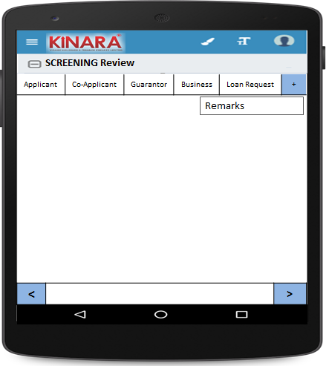

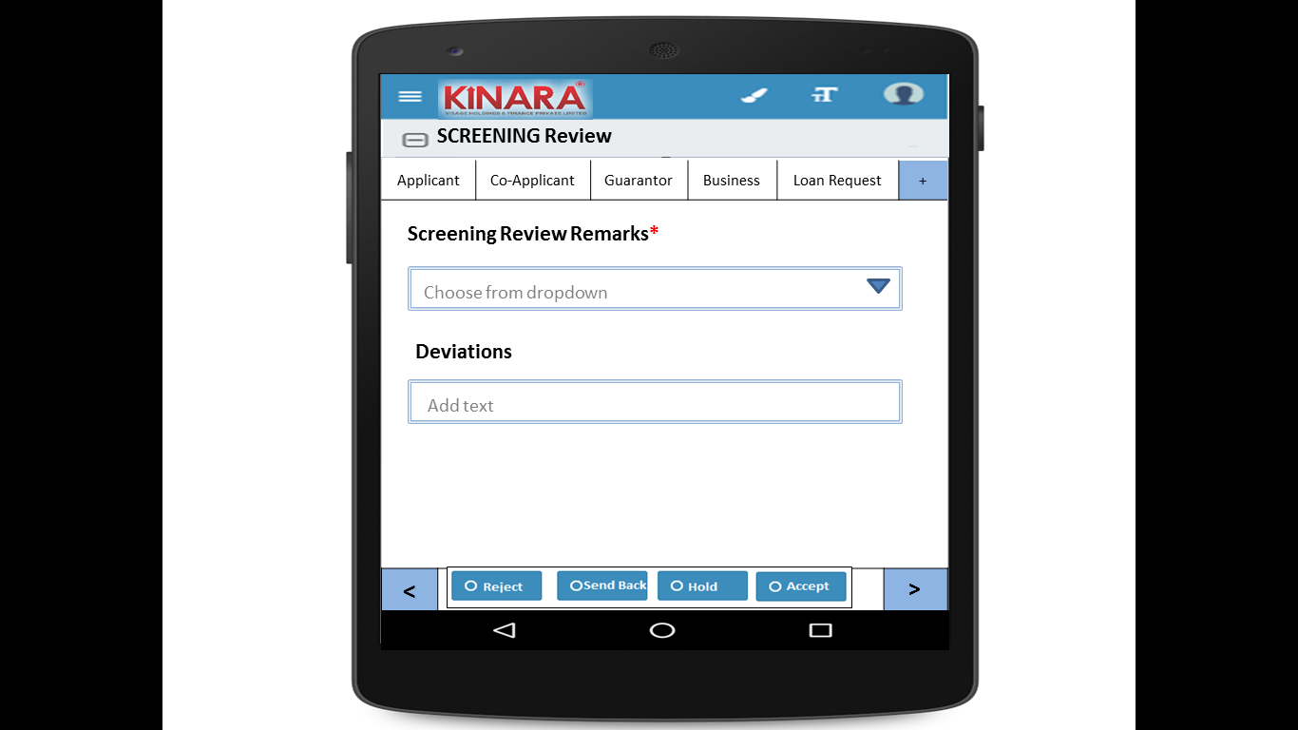

**4.2.1 Applicant**

Screening Review will start with Summary

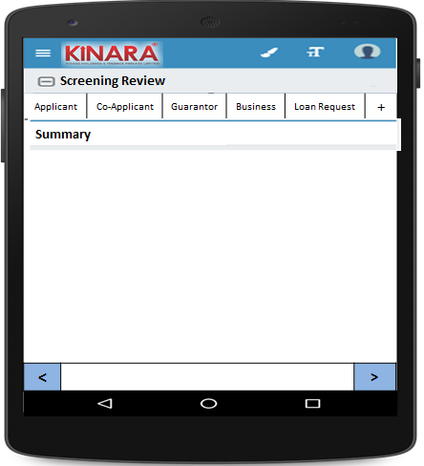

* + - 1. Summary will provide Risk Score & CB Check Report

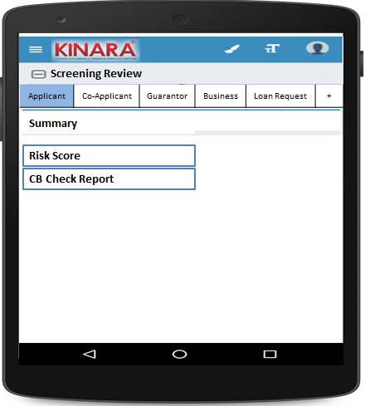

* + - 1. Risk Score

|  |  |
| --- | --- |
| Page 1 | Page 2 |

* + - 1. CB Check Report will provide Reports for Applicant, Co-applicants & Business

|  |  |
| --- | --- |
| Page 1 | Page 2 |
| Page 3 | Page 4 |

* + - 1. Applicant Details

|  |  |
| --- | --- |
| Page 1 | Page 2 |
| Page 3 | Page 4 |

* + - 1. Address Details

|  |  |
| --- | --- |
| Page 1 | Page 2 |
| Page 3 | Page 4 |

* + - 1. Liabilities

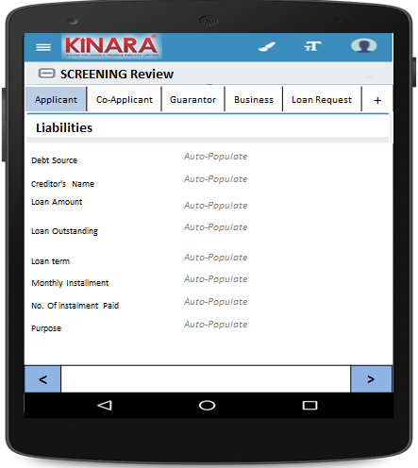

* + - 1. Bank Statement Details

|  |  |
| --- | --- |
| Page 1 | Page 2 |

* + 1. **Co-applicant**

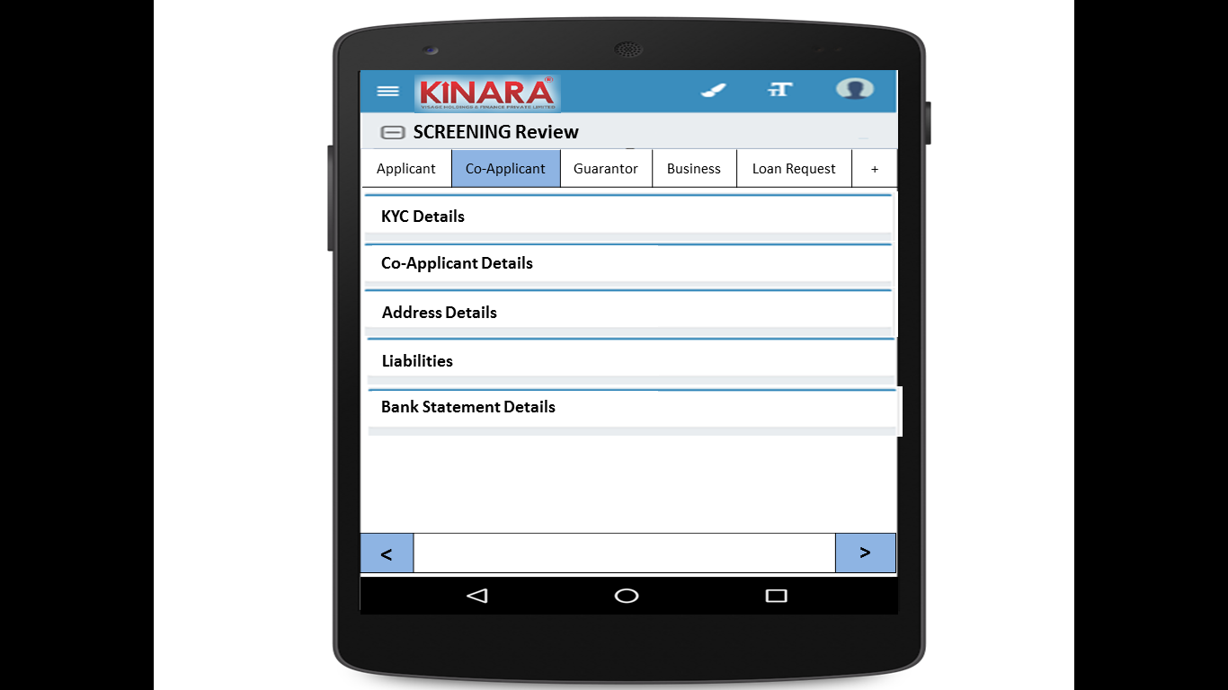

* + - 1. KYC Details

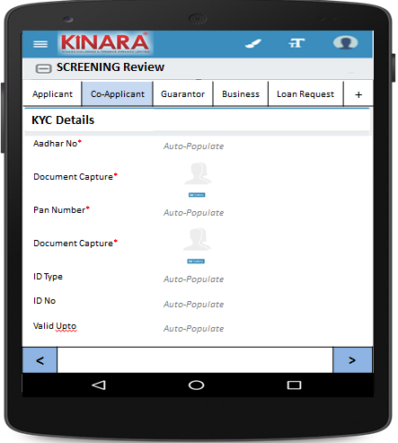

* + - 1. Co-applicant Details

|  |  |  |
| --- | --- | --- |
| Page 1 | Page 2 | Page 3 |

* + - 1. Address Details

|  |  |
| --- | --- |
| Page 1 | Page 2 |
| Page 3 | Page 4 |

* + - 1. Liabilities

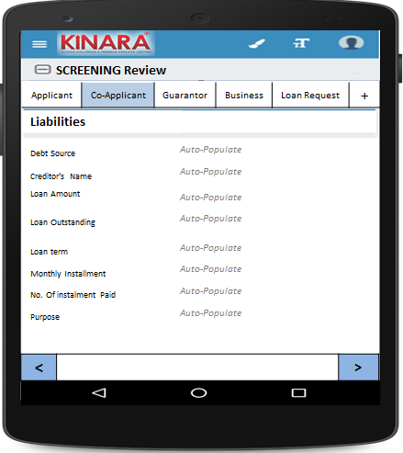

* + - 1. Bank Statement Details

|  |  |
| --- | --- |
| Page 1 | Page 2 |

* + 1. **Guarantor**

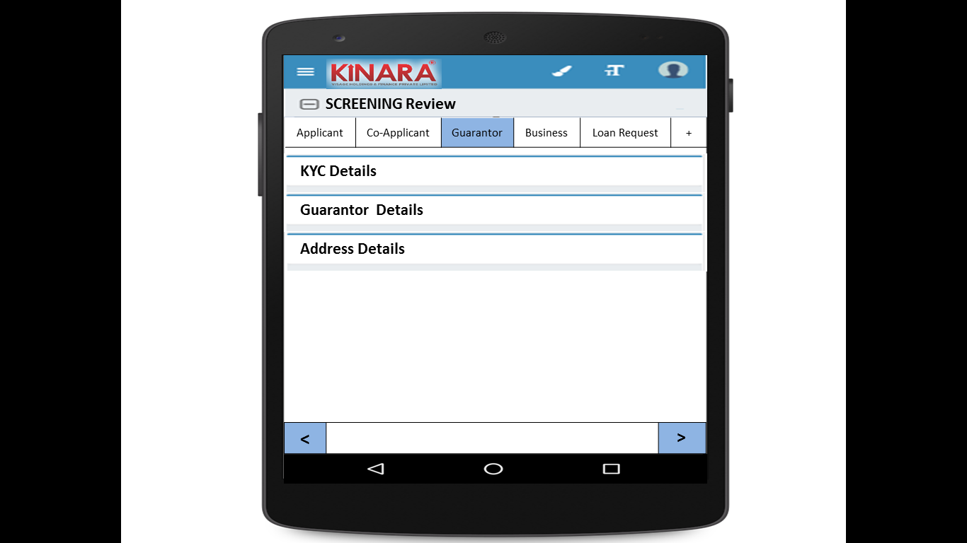

* + - 1. KYC Details

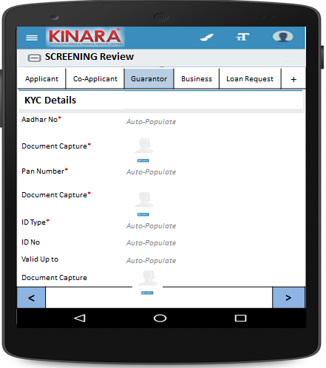

* + - 1. Guarantor Details

|  |  |  |
| --- | --- | --- |
| Page 1 | Page 2 | Page 3 |

* + - 1. Address Details

|  |  |
| --- | --- |
| Page 1 | Page 2 |
| Page 3 | Page 4 |

* + 1. **Business**

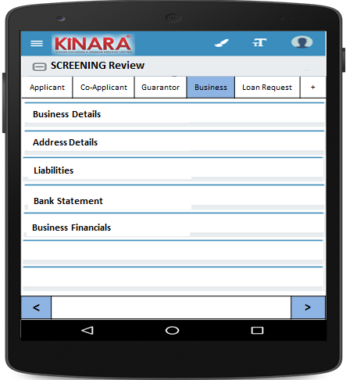

* + - 1. Business Details

|  |  |  |
| --- | --- | --- |
| Page 1 | Page 2 | Page 3 |

* + - 1. Address Details

|  |  |
| --- | --- |
| Page 1 | Page 2 |

* + - 1. Business Financials

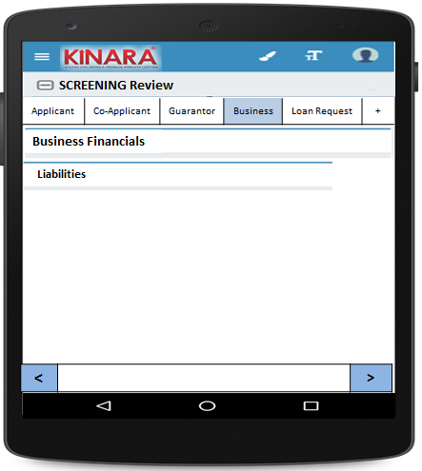

* + - * 1. Liabilities

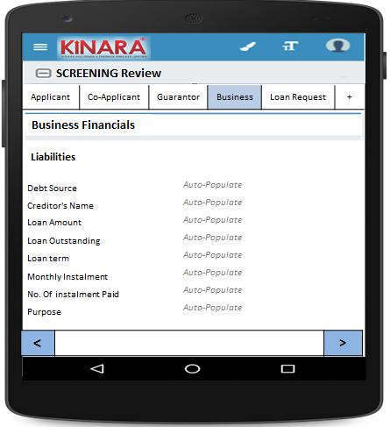

* + - 1. Bank Statement

|  |  |
| --- | --- |
| Page 1 | Page 2 |

* + - 1. Business Financials

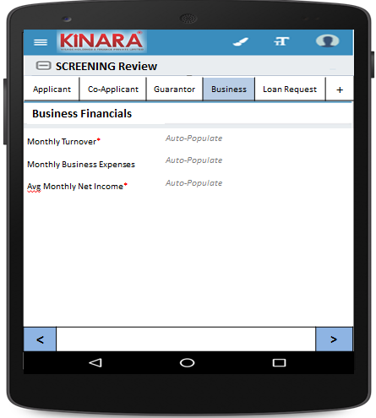

* + 1. **Loan Request**

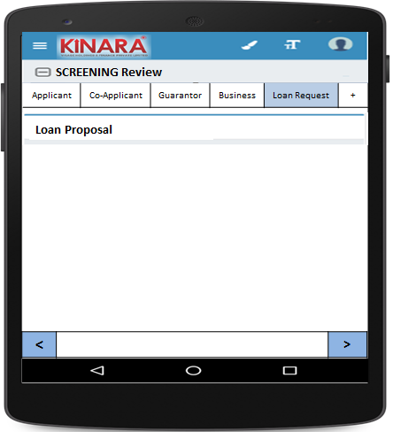

* + - 1. Loan Proposal

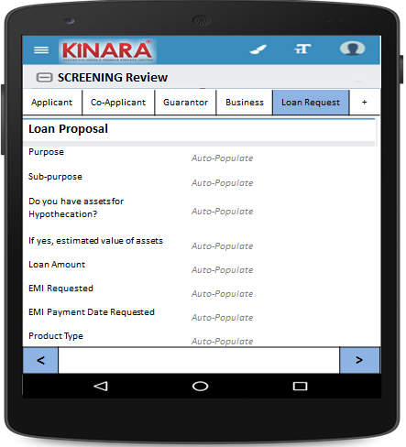

## Functional requirements

* 1. Once the profile is completed from the Screening queue, the Central Risk Manager reviews the screening details data and enters remarks. Based on the review s/he can submit and move profile to next stage or send back to screening stage or Hold in the screening review queue until further action or reject.
  2. All profiles submitted will be sent to application stage.
  3. All profiles sent back will appear in screening queue with tag ‘**Sent back from Screening Review’**
  4. Uploads

-NA-

## Downloads

-NA-

## Reports

-NA-